DATA ANALYTICS

Assignment 3

Name:Kasara padmaja

* Define at least two sets based on specific criteria from your dataset (e.g., high-value customers, top-performing products).

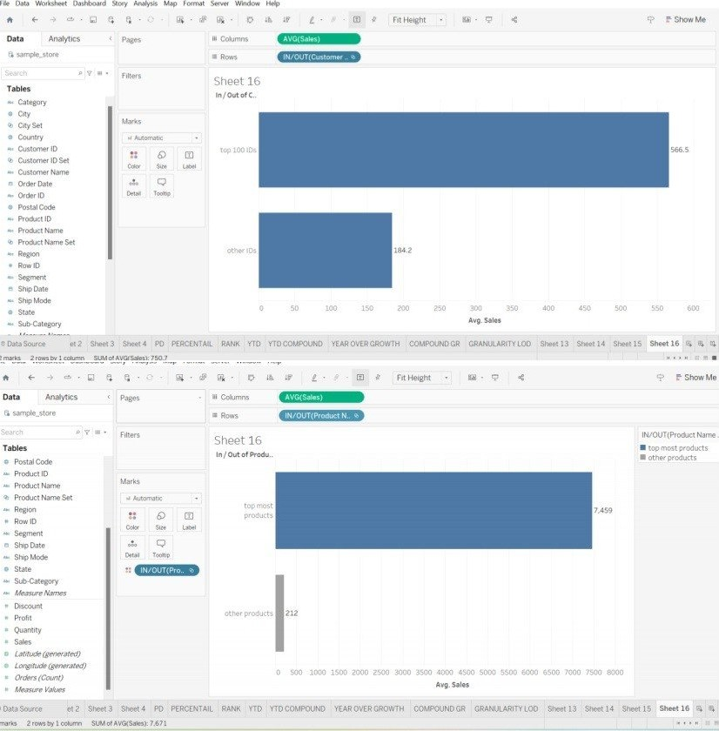

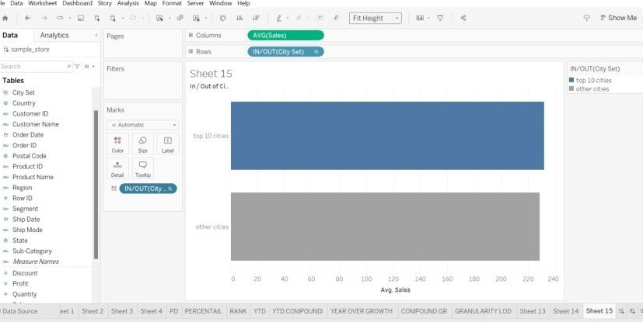

* Experiment with combining sets using UNION, INTERSECT, and MINUS operations.

# MINUS, INSERT, UNION

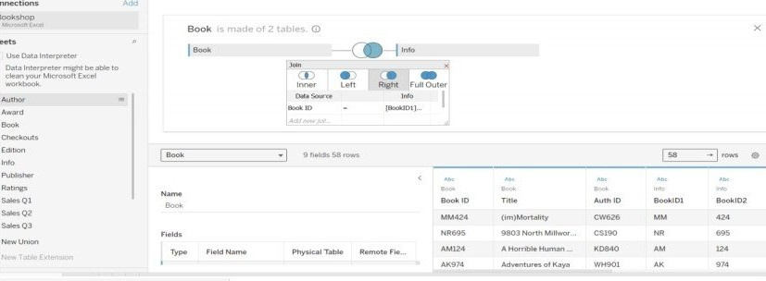

onnections Add

Bookshop

Microsoft Excel

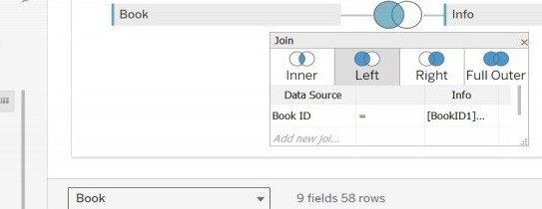

Book

is

made

of

2

tables.

o

Use

Data

Interpreter

Data

Interpreter

might

be

able

to

clean

your

Microsoft

Excel

work

boo

k.

Author

Award

Book

Checkouts

Edition

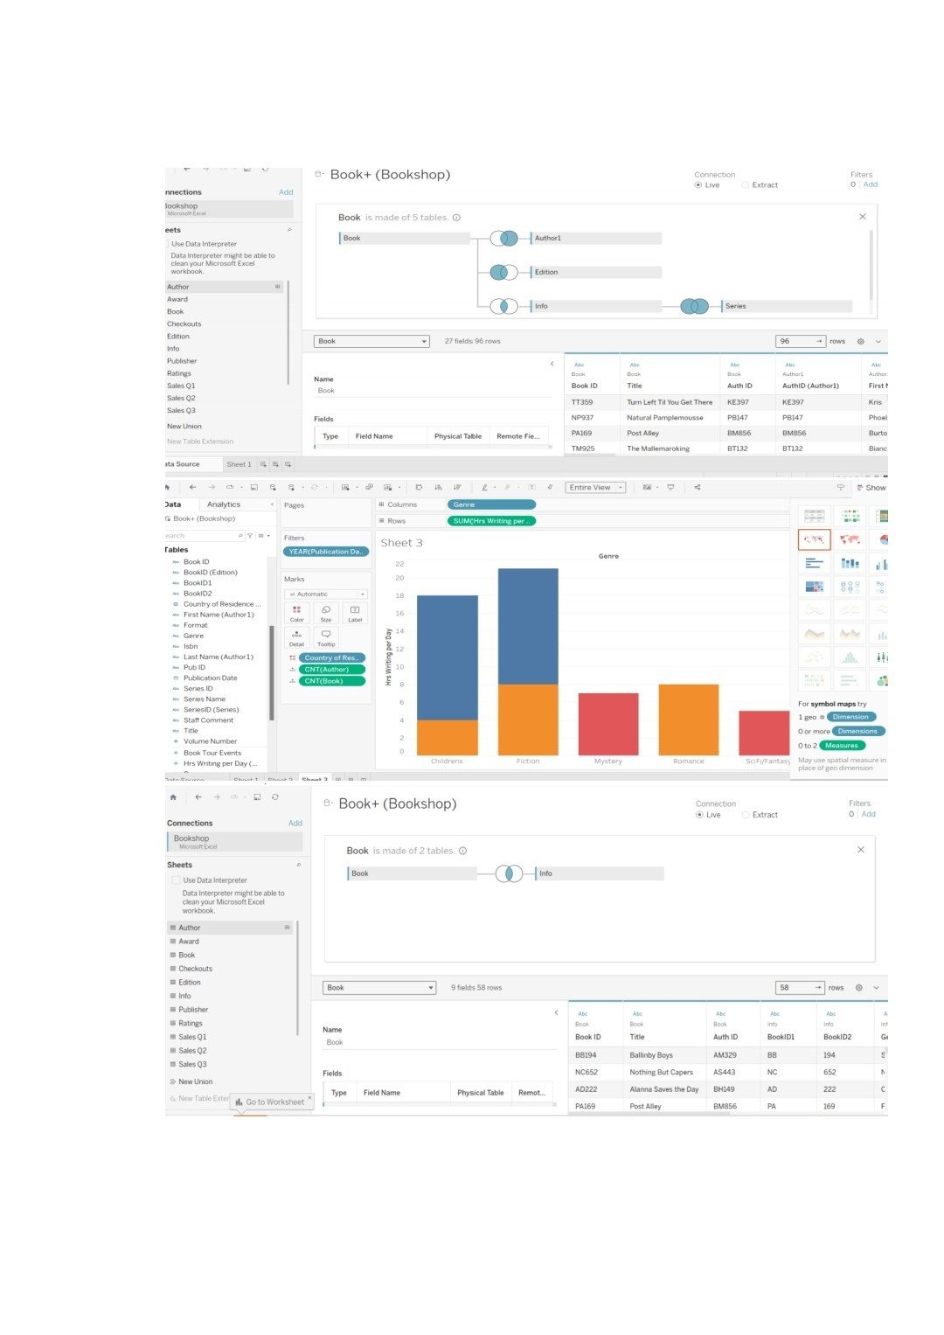

 Create 2 Calculation field using any aggregate function

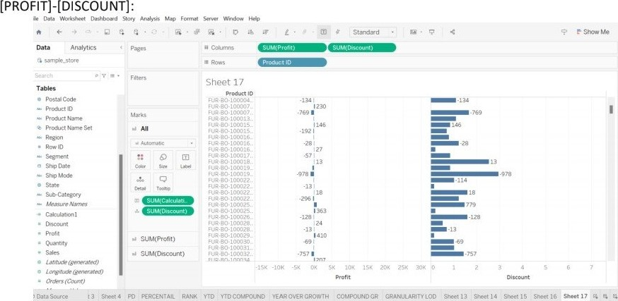

IF[PROFIT] > o THEN "PROFITABLE" ELSE "NON PROFITABLE" END

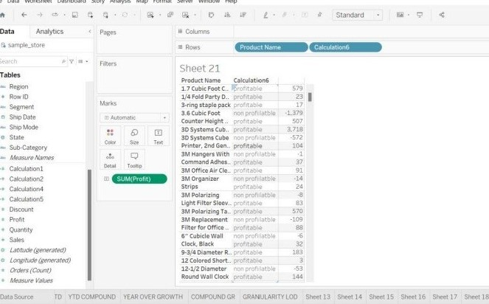Show Me

Sheet 19 Sheet 20

([PROFIT] - [DISCOUNT]) /

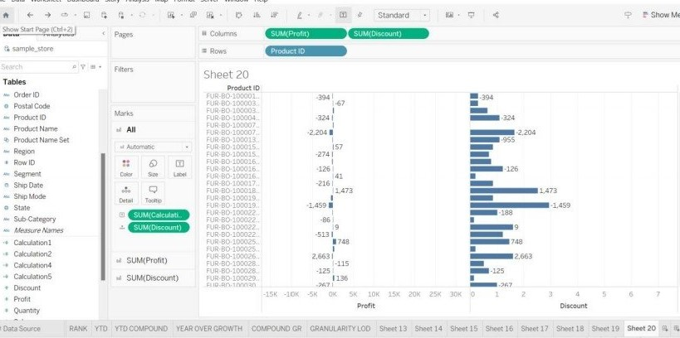

 3 visualization using quick Table Calculations Dataset

COMPOUND GROWTH RATE:

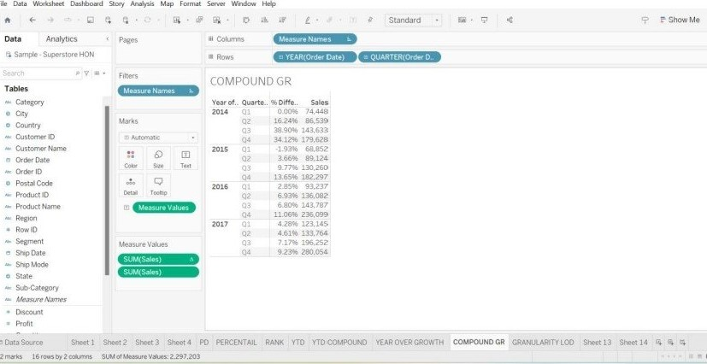

PERCENTAIL

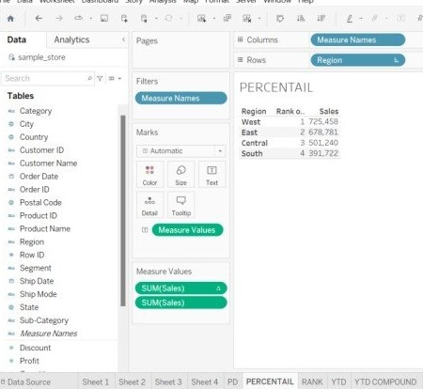Sta d

YEAR OVERGROWTH coupoUND GR GRANULARITY LOD 

YEAR TO DATE:

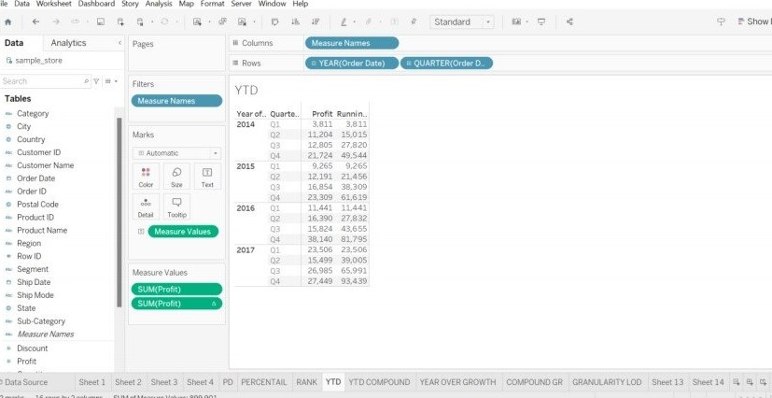

YEAR TO DATE COMPOUND:

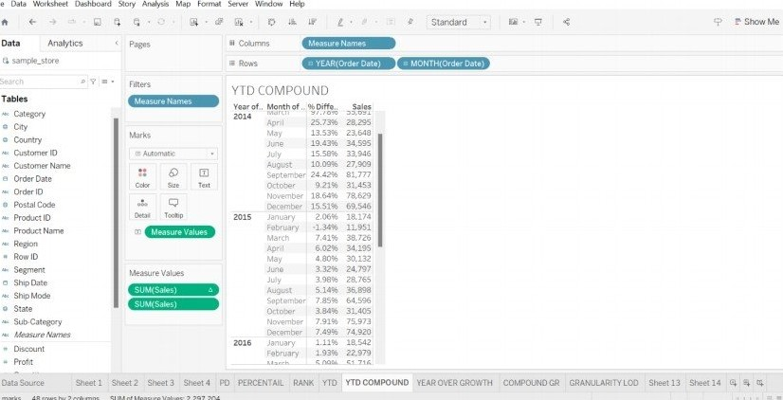

Bookshopxlsx

Sample - Superstore

(5)xls